# Fop lab 7(lab tasks)

## Name: Muhammad Usman Bhutto.

## Cms id: 453891.

## Section: B.

**Task 1:**

#include<iostream>

using namespace std;

int main()

{

int size;

cout<<"enter size of Array:";

cin>>size;

int array[size];

for(int i=0;i<size;++i)

{

cin>>array[i];

}

for(int i=0;i<size;++i)

{

cout<<array[i];

}

return 0;

}

**Output:**

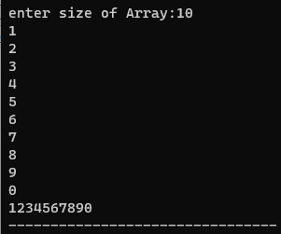

**Task 2:**

#include<iostream>

using namespace std;

int main()

{

int array[5];

for(int i=0;i<5;++i)

{

cout<<"element"<<i+1<<": ";

cin>>array[i];

}

int sum=0;

for(int i=0;i<5;++i)

{

sum+=array[i];

}

cout<<"the sum of elements is:"<<sum<<endl;

int product=1;

for(int i=0;i<5;++i)

{

product*=array[i];

}

cout<<"the product of elements is:"<<product<<endl;

return 0;

}

**Output:**

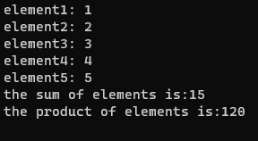

**Task 3:**

#include <iostream>

#include <cmath>

using namespace std;

int main() {

int n;

cout << "Enter the number of rows for the diamond: ";

cin >> n;

if (n % 2 == 0) {

cout << "Please enter an odd number for a symmetric diamond." <<endl;

return 1;

}

int spaces = n / 2;

for (int i = 0; i < n; ++i) {

for (int j = 0; j < spaces; ++j) {

cout << " ";

}

for (int k = 0; k < n - 2 * spaces; ++k) {

cout << "*";

}

cout <<endl;

if (i < n / 2) {

spaces--;

} else {

spaces++;

}

}

return 0;

}

**Output:**

